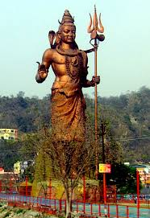
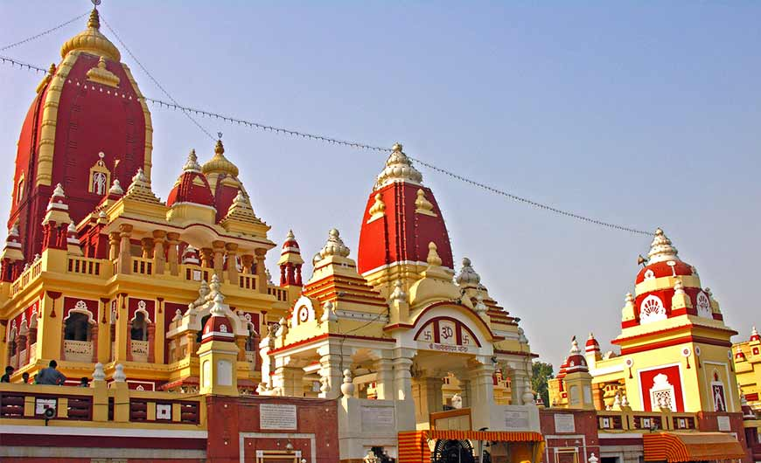
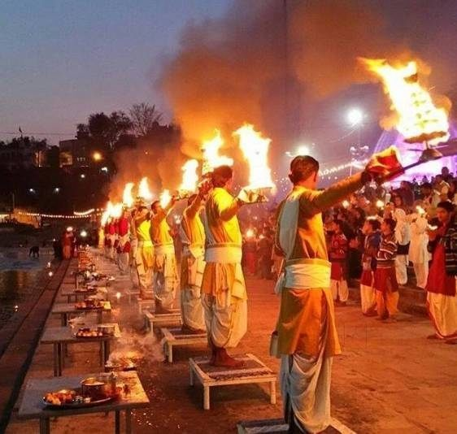
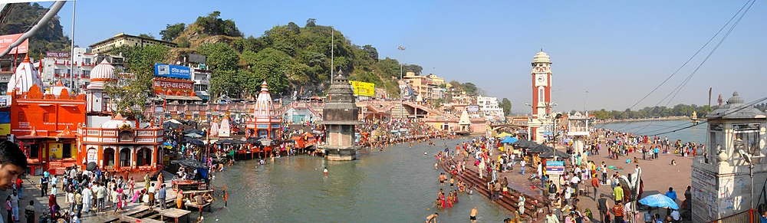
HINDU TIRTHAYATRA
RIVER GANGES, HARIDWAR
HINDU PILGRIMAGE TOUR - 4 NIGHTS / 5 DAYS
Tour code: #SHP18

Destination Covered:
Delhi– Haridwar – Rishikesh – Mathura - Vrindavan – Delhi

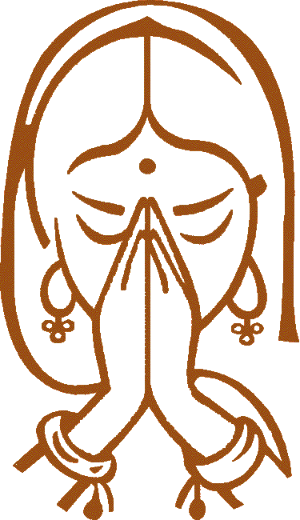

DETAILED ITINERARY

Day 01:- Arrive Delhi (No Meals)
Welcome on arrival. Our airport representative will met with guest in airport and assist them to transfer in hotel. Overnight stay at hotel.

Day 02:- Delhi – Haridwar (B/L/D)
Early b'fast and drive toward Haridwar. Enroute visit Kurukshetra - the place where the great epic battle of Mahabharata taught man righteous action. Arrive and proceed to visit Sannihit Sarovar, Sri Krishna Museum, Brahma Sarovar, Sthaneshwar Mahadev Temple, Jyotisar Birthplace of Bhagavad Gita & Krishna Museum.

Later on Continue to Haridwar. On arrival check in to the hotel. Evening visit Har-ki-Pauri (the footstep of God) - one of the most sacred ghats for Hindu in India. Back to hotel for relax and overnight.

Day 03:- Haridwar – Rishikesh – Haridwar (B/L/D)
Early b'fast and proceed to visit temples include Pareshwar Mahadev Temple, Daksha Mahadev Temple and Mansa Devi Temple, here we take Gondola ride to reach Mansa Devi temple. Afternoon, we proceed for an excursion tour of Rishikesh – pilgrimage and Yoga Center. Start our guided tour and visit Ram Jhula. Lakshman Jhula, Bharat Temple, and Trivani Ghat. In the evening back to Hotel for overnight stay.

Day 04:- Haridwar - Delhi – Mathura (B/L/D)
Early breakfast & drive toward Mathura. Stop en-route for lunch and relax. Then continue drive toward Mathura. On arrival check in to the hotel. Overnight in hotel.

Day 05:- Mathura - Vrindavan – Delhi Departure (B/L/D)
After breakfast, proceed to visit Mathura, a little town on the River Yamuna was transformed into a place of faith after Lord Krishna was born here which makes Mathura an important place of Pilgrimage today. Visit the Birth Place of Lord Krishna and also visit some other temples of Mathura. Then proceed to visit Vrindavan located 9.6 km from Mathura, first visit to the most notable Krishna Balram Mandir popularly known as ISKCON temple in Vrindavan.

Afternoon, lunch and drive toward Delhi. On arrival, proceed for dinner in local restaurant and then transfer to Delhi airport to catch flight for onward destination.

**END OF TOUR WITH BEAUTIFUL MEMORIES**

HINDU TIRTHAYATRA TOURS: (#SHP18 – 4N/5D): VALIDITY FROM JUN TILL SEP’2018
QUOTATION: USD PER PERSON | 3 STAR | 4 STAR | 5 STAR | Transportation type
Min. of 02 person | $305 | $328 | $345 | 02 Seater Car
Min. of 03 – 04 person | $287 | $310 | $327 | 04 Seater Car
Min. of 05 – 07 person | $284 | $308 | $324 | 09 Seater Van
Min. of 08 – 09 person | $260 | $283 | $299 | 10/12 Seater Van
Min. of 10 – 11 person | $251 | $274 | $291 | 18/27 Seater Mini Coach
Min. of 12 – 14 + 00 FOC person | $245 | $268 | $284 | 35 Seater Large Coach
Min. of 15 – 19 + 01 FOC person | $225 | $248 | $265 | 35 Seater Large Coach
Single room Supplement | $89 | $100 | $108

ADDITIONAL ACTIVITIES
Special prayer / puja at Haridwar | USD 25 PP | XXX | XXX

HOTELS USE
CITY | 3 STAR | 4 STAR | 5 star
DELHI | Gulnar / S.K. Premier / Tulip Inn / Similar | Ashok Country Resorts / Udman Resorts / Similar | Piccadilly / ITC Dwarka / Similar
HARIDWAR | Hotel Lakshya / Similar | Godwin hotel / Similar (4 star) | Godwin Hotel / Similar (4 star)
MATHURA | Govardhan hotel / Similar | Nidhivan Sarovar Portico / Hotel Royal Bharti / Similar (4 star) | Nidhivan Sarovar Portico / Hotel Royal Bharti / Similar (4 star)

INCLUSION / EXCLUTION
COST INCLUDES | COST EXCLUDES
- 04 Nights hotel accommodation in respective hotel on dbl/twn room.  - Meals: all Meals as per the itinerary mention.  - A/c transport for all airport transfers & sightseeing as per program.  - English speaking local spot guide (2-4 pax)  - English speaking throughout guide (5 pax onward)  - Monument & museum fee as per program.  - Gondola ride in Mansa Devi Temple  - Rishkaw Ride in Haridwar, Rishikesh, Mathura.  - Boat ride in River Ganges  - All applicable Taxes. | - Any Airfare Domestic / Int’l  - Any Visa fee  - Any insurance / tipping  - Any personal nature expense.  - Surcharge would be applicable for Xmas & New years.

POINT TO NOTIC
- Above package is Valid FROM JUN – SEP’2018
- 01 FOC (free of cost) can be offer on min of 15 paying guest.
- For 20 & above pax group, please send mail on: info@sumanyatours.com Or Sumanyatours@gmail.com for special rate.
- In Mathura & Haridwar, all meals are vegetarian and serve at same hotel, In Delhi, meals serve at local restaurant choice of Indian, Chinese & local menu.
- Child policy: 0- 5yrs = Free, 5 – 12 yrs (with bed) = 80% of adult, 5 – 12 yrs (without bed) = 60% of adult, 12 yrs Onward is adult.
- For India visa can apply via online: https://indianvisaonline.gov.in/visa/index.html
- Best time to visit India Oct – Mar. for more information: https://www.accuweather.com
- Hotel rooms are subject to availability. If mention hotel are not available then alternate hotel will be suggest.
- Above cost are based on base category of room. Additional charge would be applicable for higher room category.

